**Introduction**

This document covers the two (application) templates “Specification Mass Update” and “Specification Import/Export”. It is about the nitty gritty technical, behind the scenes stuff in the template code itself. How to set it up to fit you needs.

There is a section in the template where you can customize certain aspects of the template. Both templates have some common features and some features that is specific for that template.

**Common Features**

There is a section in the Html Templates that looks like this:

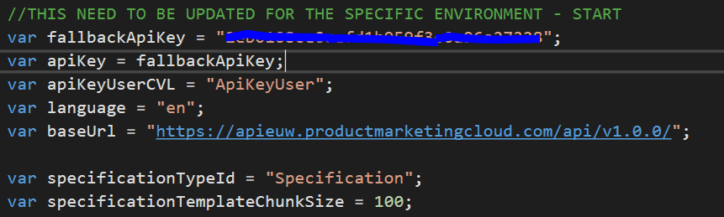

The Api Key is needed for accessing the Rest Api. There is a feature that simulates user context logins. It is based on a CVL which contain, key = Api Key and Value = Username. This CVL must be set up and maintained by either partner or customer. You must set the Id of the CVL by setting the ‘**apiKeyUserCVL**’ variable.

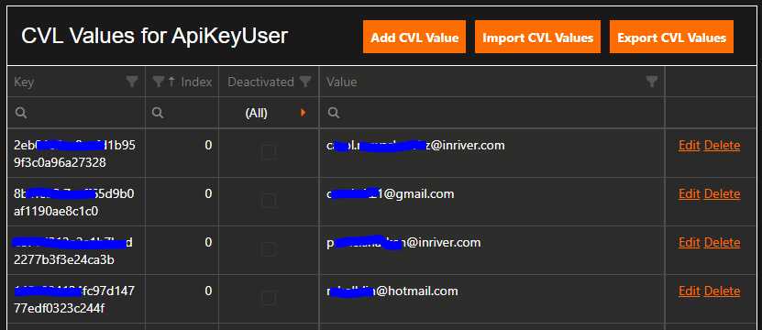

If you do not have set up the CVL or have an unmatched entry it will go to the ‘**fallbackApiKey**’ variable. This **must** be set with a valid REST Api Key.

The ‘**language**’ is setting the default language of the template. See Control Center for valid language codes.

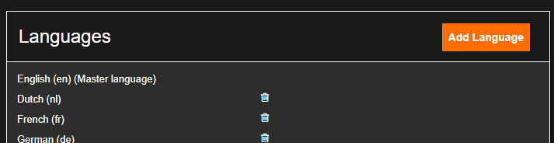

The ‘**specificationTypeId**’-variable is the entity type of the Specification entity.

The ‘**specificationTemplateChunkSize**‘-variable is setting the size of the chunks to fetch entities for a specific work area. So, if the work areas have 987 entities there will be 10 chunks of data fetched. 9 with a hundred entities each and on with 87 entities. The reason for this is:

* Fetching a limited number of items takes shorter time than fetching the whole batch at once.
* If this is done in parallel, ten chunks with 100 entities each will take an overall time that is shorter than fetching all at once.
* The REST Api has a limitation of running 10 simultaneous requests. To limit the number of simultaneous requests is called throttling and is applied in the template.

**Template specific features - Import/Export**

The Import/Export template has some additional features that **must** be set up. Before doing this, you must gather some information from the customer. The excel/csv file is divided into columns. Those columns are in turn divided into two sections:

1. Entity Id and Specification section
2. Fields section

A **must** is always to have a column with the sys id of the entity and the specification name. The sys id of the entity **must** always be in the first column. As this is the base on which the template is resting on. In the below excel there is three columns, that are not Fields: EntityId, ProductNumber and SpecificationName:

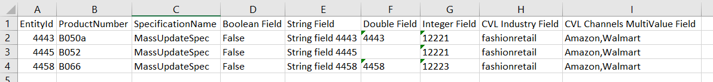

These first three columns are specified with the following array of paired methods. Per array entry there is a method for the column name, the columnName method, and a method, the exportOperation method, for which value each row under the column name should have, based on the entity.

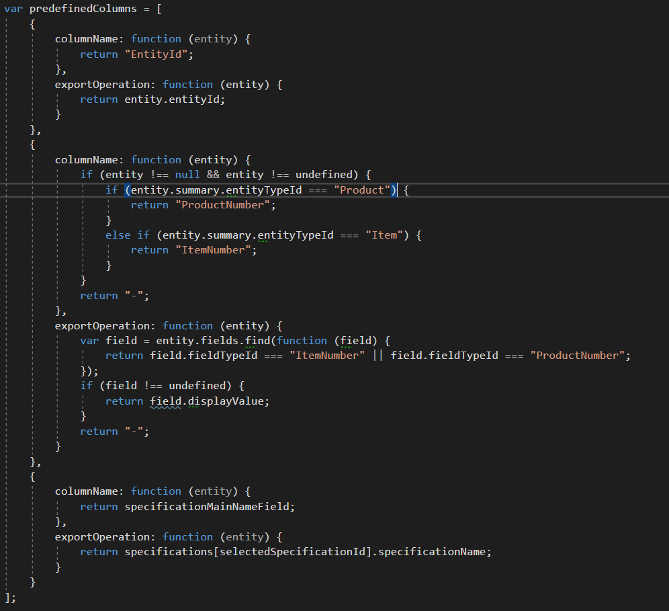

Another thing that is also dynamic is a method for making a validation error more readable. The method called in this case is the ‘validationAdditionalEntityInformation’-function.

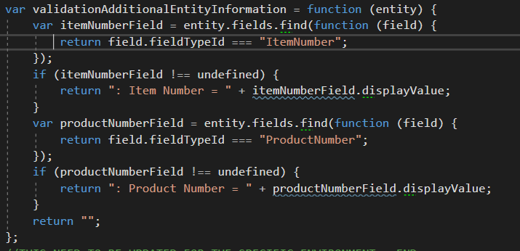

What the method is doing is to generate this text (yellow marking):

